**MONGO DB**



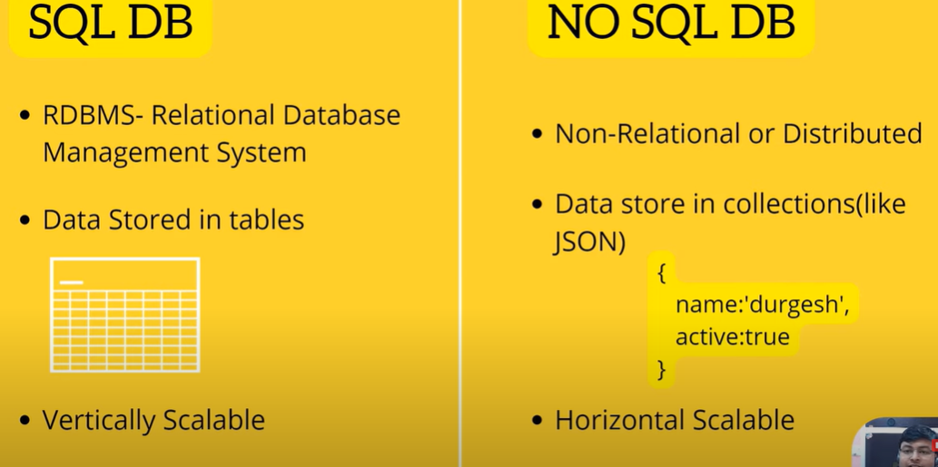

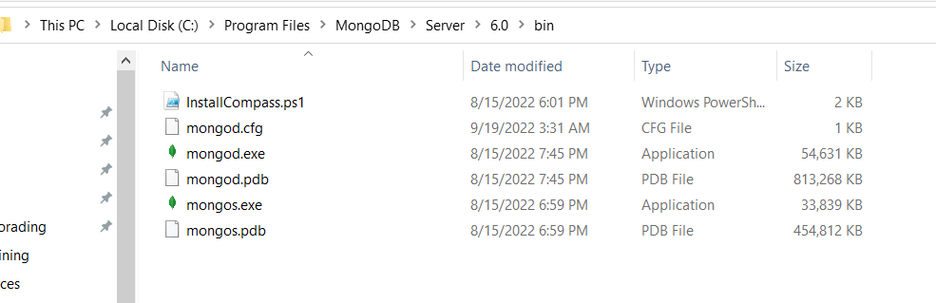

C drive > Program Files > Mongo DB > Server > 6.0 > bin

Is path par akar cmd open kar k server start karenga

**mongod** kar k server start karengay

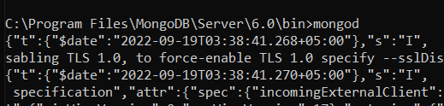

Phr us k baad apna client chalyengay

**Mongosh** kar k client chalay ga

ya direct mongo shell open karlo

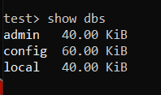

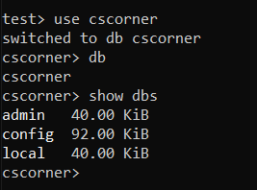

If the collection is not created it does not show in database

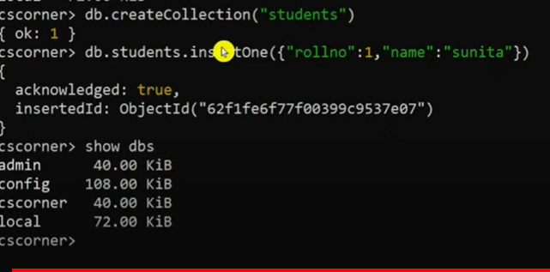

If you want to see how many collections are there in your database

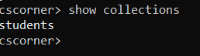

If you want to see collection values

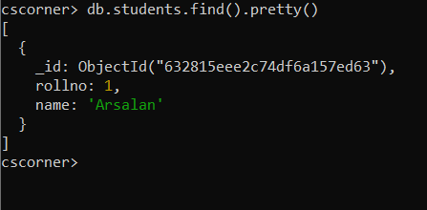

Now drop this collection

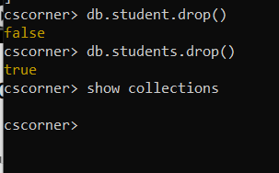

Now drop the database

